i
Birmingham Catholic Schools
Sports Association (BCSSA)

Bill McCarthy Memorial Games
Catholic Athletics Sports


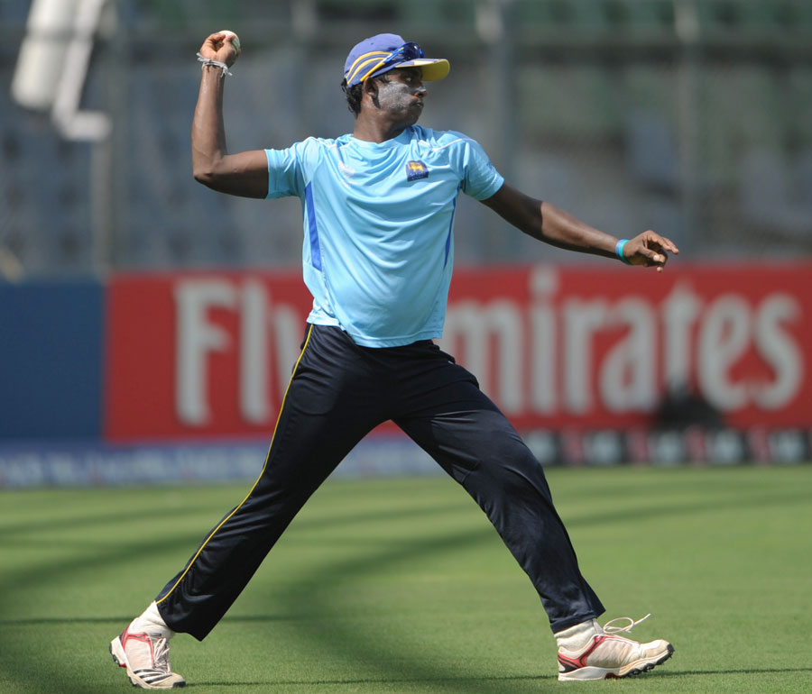
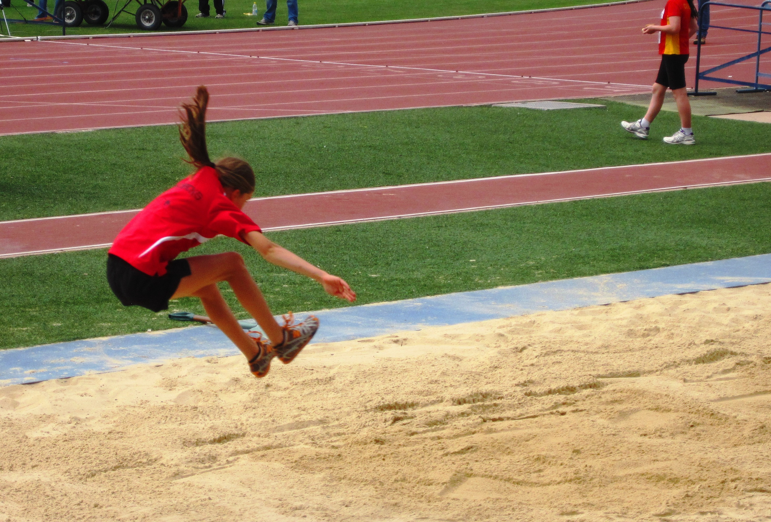

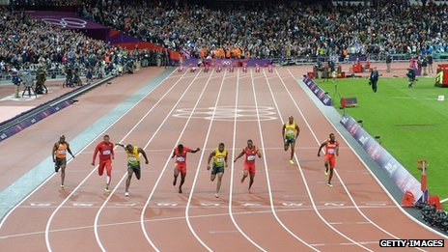

Admission - free

Children must be accompanied by an teacher/adult

Order of Events

All the following events are WITHOUT running spikes. i.e. trainers are to be worn, pumps are accepted too, however, they do not support the foot as much as a trainer

EVENT 1: MIXED TEAM RELAY - 4 X 100M
EVENT 2: Relay Finals will follow straight away before other sprints so children can go to field events too

EVENT 3: BOYS UNDER 9 (Y4) SPRINT 60M

EVENT 4: GIRLS UNDER 9 (Y4) SPRINT 60M

EVENT 5: BOYS UNDER 10 (Y5) SPRINT 70M

EVENT 6: GIRLS UNDER 10 (Y5) SPRINT 70M

EVENT 7: BOYS UNDER 11 (Y6) SPRINT 80M

EVENT 8: GIRLS UNDER 11 (Y6) SPRINT 80M

The field events all happen at the same time and as the sprints are being done.
EVENT 9: BOYS HIGH JUMP
EVENT 10: GIRLS HIGH JUMP

EVENT 11: BOYS CRICKET BALL THROW
EVENT 12: GIRLS ROUNDERS BALL THROW

EVENT 13: BOYS LONG JUMP
EVENT 14: GIRLS LONG JUMP

EVENTS 15 - 20: Will be the finals of each year group sprint in order of year group.

EVENT 21: BOYS OPEN 800M
EVENT 22: GIRLS OPEN 800M

Certificates for 1st, 2nd, and 3rd places are given out throughout the afternoon and school shields are awarded at the end. Children who finish in the top 8 places win pints for their schools that go towards the awards. Given time restraints, these may not be awarded on the night but sent to the schools before end of term for their assemblies to celebrate. Thank you for your patience and support.

Notice to all guests

Encourage all competitors to do their best.
Thank staff and parents that have given up their time to support the event.
Accept all decisions made by officials and judges.
Respect the rules and regulations set out by Alexander Stadium.
Follow advice and requests from stewards and teaching staff.

Lanes for all track races

Due to late confirmation emails from schools, the running lanes will be given out on the night. Every school will be given a lane, like last year. This lane will be the only lane your school uses.

Thank you for you co-operation. I look forward to seeing everyone at the stadium.

Mrs Kennedy – Event Organiser

Please note that the fastest children, from ALL the heats, in their year band sprints, will go through to the finals of each event! (Not the winners of each race.) This is why every heat is timed. Please do not question the judges on the night, we do our best!

